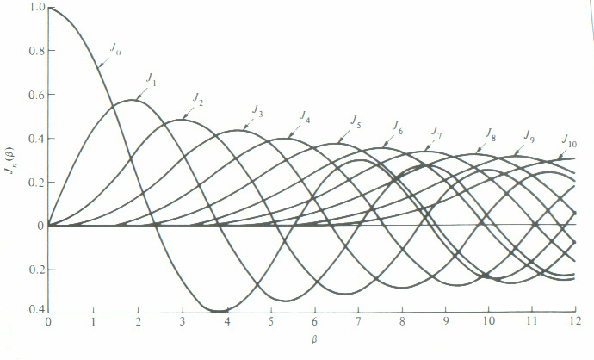

Bessel curves. β is the same as m = Δf/fm

